Economics Assignment 2

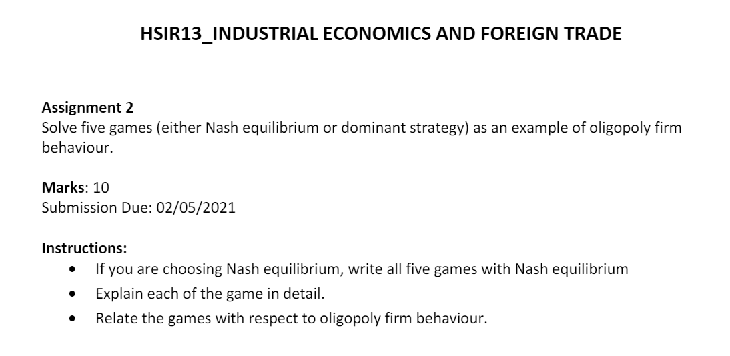

Topic Chosen: *NASH EQUILIBRIUM*

Group Members (2):

1. Rajneesh Pandey - 106119100
2. Satyarth Pandey – 106119112
3. A Stag Hunt Game

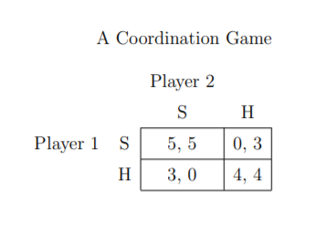

This is an example of a coordination game, as depicted in Table above. This game might be thought of as selecting between two technologies or coordinating on a meeting location. Players earn higher payoffs when they choose the same action than when they choose different actions. There are two (pure strategy) Nash equilibria: (S, S) and (H, H).

This game is also a variation on Rousseau’s “stag hunt” game. The story is that two hunters are out, and they can either hunt for a stag (strategy S) or look for hares (strategy H). Succeeding in getting a stag takes the effort of both hunters, and the hunters are separated in the forest and cannot be sure of each other’s behaviour.

If both hunters are convinced that the other will hunt for stag, then hunting stag is a strict or unique best reply for each player. However, if one turns out to be mistaken and the other hunter hunts for hare, then one will go hungry. Both hunting for hare is also an equilibrium and hunting for hare is a strict best reply if the other player is hunting for hare.

This example hints at the subtleties of making predictions in games with multiple equilibria. On the one hand, (S, S) (hunting stag by both) is a more attractive equilibrium and results in high payoffs for both players.

Indeed, if the players can communicate and be sure that the other player will follow through with an action, then playing (S, S) is a stable and reasonable prediction. However, (H, H) (hunting hare by both) has properties that make it a useful prediction as well. It does not offer as high a payoff, but it has less risk associated with it. Here playing H guarantees a minimum payoff of 3, while the minimum payoff to S is 0.

When costs and benefits are balanced so that no firm wants to break from the group, it is considered the **Nash equilibrium state for oligopolies**. This can be achieved by contractual or market conditions, legal restrictions, or strategic relationships between members of the oligopoly that enable the punishment of cheaters.

1. Battle of the Sexes

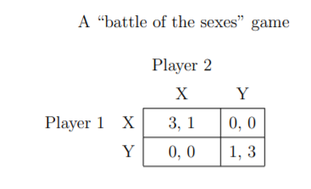

The next example is another form of coordination game, but with some asymmetries in it. It is generally referred to as a “Battle of the Sexes” Game, as depicted in Table above.

The players have an incentive to choose the same action, but they each have a different favourite action. There are again two (pure strategy) Nash equilibria: (X, X) and (Y, Y).

Here, however, player 1 would prefer that they play equilibrium (X, X) and player 2 would prefer (Y, Y). The battle of the sexes title refers to a couple trying to coordinate on where to meet for a night out. They prefer to be together, but also have different preferred outings.

This presents an interesting case for game theory since each of the Nash equilibria is deficient in some way. The two pure strategy Nash equilibria are unfair; one player consistently does better than the other.

The mixed strategy Nash equilibrium (when it exists) is inefficient. The players will mis coordinate with probability 13/25, leaving each player with an expected return of 6/5 (less than the return one would receive from constantly going to one's less favoured event).

If firm 2 decided to flood the Oligopolistic market with product and drive the price down to zero, for example, firm 1 would not choose y1∗. Rather, firm 1 would produce zero and save its production costs. This shows that producing y1∗ is **not a dominant strategy** for firm 1. The same argument applies to firm 2. (Here y1∗ is firm 1’s output, and y2∗ is firm 2’s.)

1. Hawk-Dove and Chicken Games

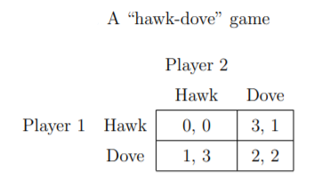

There are also what are known as anti-coordination games, with the prototypical version being what is known as the hawk-dove game or the chicken game, with payoffs as in Table above.

Here there are two pure strategy equilibria, (Hawk, Dove) and (Dove, Hawk). Players are in a potential conflict and can be either aggressive like a hawk or timid like a dove.

If they both act like hawks, then the outcome is destructive and costly for both players with payoffs of 0 for both. If they each act like doves, then the outcome is peaceful, and each gets a payoff of 2. However, if the other player acts like a dove, then a player would prefer to act like a hawk and take advantage of the other player, receiving a payoff of 3.

If the other player is playing a hawk strategy, then it is best to play a dove strategy and at least survive rather than to be hawkish and end in mutual destruction.

If each of the **oligopolists** cooperates in holding down output, then high monopoly profits are possible. Each oligopolist, however, must worry that while it is holding down output, other firms are taking advantage of the high price by raising output and earning higher profits. If both Firms agree to hold down output, they are acting together as a monopoly and will each earn good profits.

4) The Driving Game

|  |  |  |
| --- | --- | --- |
| **Driver 2**  **Driver 1** | **Drive on the Left** | **Drive on the Right** |
| **Drive on the Left** | 10  10 | 0  0 |
| **Drive on the Right** | 0  0 | 10  10 |

Driving on a road against an oncoming car and having to choose either to swerve on the left or to swerve on the right of the road, is also a coordination game. For example, with payoffs 10 meaning no crash and 0 meaning a crash, the coordination game can be defined with the above payoff matrix.

In this case there are two pure-strategy Nash equilibria, when both choose to either drive on the left or on the right. If we admit mixed strategies (where a pure strategy is chosen at random, subject to some fixed probability), then there are three Nash equilibria for the same case: two we have seen from the pure-strategy form, where the probabilities are (0%, 100%) for player one, (0%, 100%) for player two; and (100%, 0%) for player one, (100%, 0%) for player two, respectively. We add another where the probabilities for each player are (50%, 50%).

This example of a coordination game is the setting where two technologies are available to two firms with comparable products, and they must elect a strategy to become the **Oligopolistic** market standard. If both firms agree on the chosen technology, high sales are expected for both firms. If the firms do not agree on the standard technology, few sales result. Both strategies are **Nash equilibria** of the game .

5) Competition Game

|  |  |  |  |  |
| --- | --- | --- | --- | --- |
| **Player 2**  **Player 1** | **Choose '0'** | **Choose '1'** | **Choose '2'** | **Choose '3'** |
| **Choose '0'** | *0*, *0* | *2*, *−2* | *2*, *−2* | *2*, *−2* |
| **Choose '1'** | *−2*, *2* | *1*, *1* | *3*, *−1* | *3*, *−1* |
| **Choose '2'** | *−2*, *2* | *−1*, *3* | *2*, *2* | *4*, *0* |
| **Choose '3'** | *−2*, *2* | *−1*, *3* | *0*, *4* | *3*, *3* |
| ***A competition game*** | | | | |

This can be illustrated by a two-player game in which both players simultaneously choose an integer from 0 to 3 and they both win the smaller of the two numbers in points. In addition, if one player chooses a larger number than the other, then they must give up two points to the other.

This game has a unique pure-strategy Nash equilibrium : both players choosing 0 (highlighted in light red). Any other strategy can be improved by a player switching their number to one less than that of the other player. In the above adjacent table, if the game begins at the green square, it is in player 1's interest to move to the purple square and it is in player 2's interest to move to the blue square. Although it would not fit the definition of a competition game, if the game is modified so that the two players win the named amount if they both choose the same number, and otherwise win nothing, then there are 4 Nash equilibria: (0,0), (1,1), (2,2), and (3,3).

If each of the oligopolists cooperates in holding down output, then high monopoly profits are possible. Each **oligopolist**, however, must worry that while it is holding down output, other firms are taking advantage of the high price by raising output and earning higher profits. If both Firms agree to hold down output, they are acting together as a monopoly and will each earn good profits.